

<<Project name>>
Software Requirement Document
Report 4 - Functional Requirements

– HoChiMinh, August 2022 –
Table of Contents
Record of Changes 3
IV. Functional Requirements 4
1. System Functional Overview 4
1.1 Screen Flow 4
1.2 Screen Descriptions 4
1.3 Screen Authorization 4
1.4 Non-Screen Functions 5
2. Data Requirements 5
2.1 Logical Data Model 5
2.2 Data Dictionary 6
2.3 Reports 8
2.4 State transition diagram 9
3. <<Feature Name 1>> 9
3.1 <<Function Name 1>> 9
3.2 <<Function Name 2>> 10
4. <<Feature Name 2>> 10

Record of Changes
Date | A*  M, D | In charge | Change Description
*A - Added M - Modified D - Deleted

IV. Functional Requirements

1. System Functional Overview
[Provide functionality overview of software system: screen flow, screen descriptions, system user roles, screen authorization, non-screen functions, ERD]

1.1 Screen Flow
[This part shows the system screens and the relationship among screens. You can draw the Screens Flow for the system in the form of diagram as below]
<<Sample:
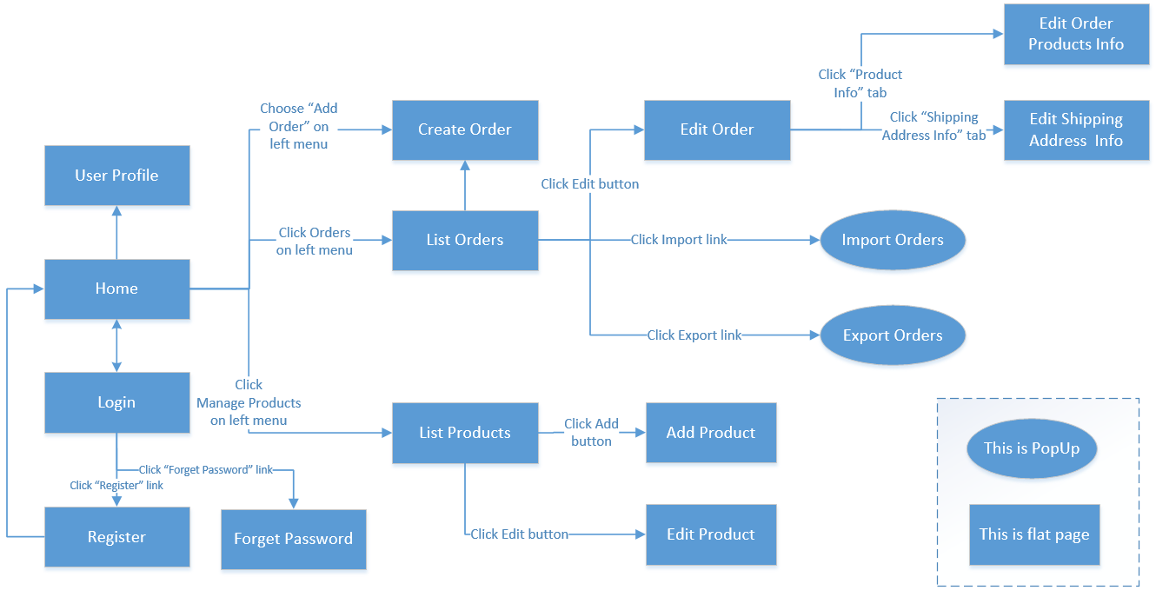
>>

1.2 Screen Descriptions
[Provide the descriptions for the screens in the Screens Flow above]
<<Sample:
# | Screen | Feature | Description
FR-01 | Create Order | Order Meals | <<Screen Brief description>>
FR-02 | Change Order | Order Meals
FR-03 | ..
>>

1.3 Screen Authorization
[Provide the system roles authorization to the system features (down to screens, and event to the screen activities if applicable) in the table form as below – replace Role1, Role2,… with the specific system user role names]
<<Sample:
Screen | Role1 | Role2 | Role3 | Role4 | RoleX
<<Screen Name1>> | X |  |  | X | X
<<Screen Activity>> |  |  |  | X | X
<<Screen Name2>> | X |  |  | X
Query All Data | X
Query Own Data |  |  |  | X
Query Managed Data |  |  |  | X
Add New Data |  |  |  | X | X
Update All Data |  |  |  |  | X
Update Own Data |  |  |  |  | X
Update Managed Data |  |  |  |  | X
Delete Data
…
In which:
- Role1: <<role1 description>>
- Role2: <<role2 description>>
- …
>>

1.4 Non-Screen Functions
[Provide the descriptions for the non-screen system functions, i.e batch/cron job, service, API, etc.]
<<Sample:
# | System Function | Feature | Description
FR-11 | <<Function Name1>> | <<Feature Name>> | <<Function Name1 Description>>
FR-12 | …
>>

2. Data Requirements

2.1 Logical Data Model
[A data model is a visual representation of the data objects and collections the system will process and the relationships between them. Include a data model for the business operations being addressed by the system, or a logical representation for the data that the system itself will manipulate. Data models are most commonly created as an entity-relationship diagram.]
<<Sample:
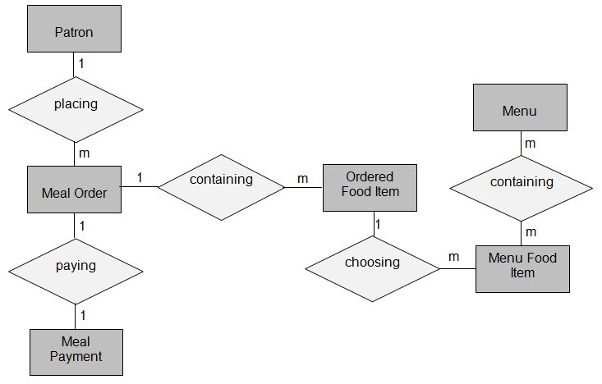
>>

2.2 Data Dictionary
[The data dictionary defines the composition of data structures and the meaning, data type, length, format, and allowed values for the data elements that make up those structures. In many cases, you're better off storing the data dictionary as a separate artifact, rather than embedding it in the middle of an SRS. That also increases its reusability potential in other projects.]
<<Sample:
Data Element | Description | Composition or Data Type | Length | Values
delivery instruction | where and to whom a meal is to be delivered, if it isn't being picked up in the cafeteria | patron name  +patron phone number  +meal date  +delivery location  +delivery time window
delivery location | building and room to which an ordered meal is to be delivered | alphanumeric | 50 | hyphens and commas permitted
delivery time window | beginning time of a 15-minute range on the meal date during which an ordered meal is to be delivered; | time | hh:mm | local time; hh = 0-23 inclusive; mm = 00, 15, 30, or 45
employee ID | company ID number of the employee who placed a meal order | integer | 6
food item description | ext description of a food item on a menu | alphabetic | 100
food item price | pre-tax cost of a single unit of a menu food item | numeric, dollars and cents | dd.cc
meal date | the date the meal is to be delivered or picked up | date, MM/DD/YYYY | 10 | default = current date if the current time is before the order cutoff time, else the next day; cannot be prior to current date
meal order | details about a meal a Patron ordered | meal order number  + order date  + meal date  + 1:m{ordered food item}  + delivery instruction  + meal order status
meal order number | unique ID that COS assigns to each accepted meal order | integer | 7 | initial value is 1
meal order status | status of a meal order that a Patron initiated | alphabetic | 16 | incomplete, accepted, prepared, pending delivery, delivered, canceled
meal payment | information about a payment COS accepted for a meal | payment amount  + payment method  + transaction number
menu | list of food items available for purchase on a specific date | menu date  + 1:m{menu food item}
menu date | the date for which a specific menu is available | date, MM/DD/YYYY | 10
menu food item | description of a menu item | food item description  + food item price
order cutoff time | the time of day before which all meal orders for that date must be placed | time, HH:MM | 5
order date | the date on which a patron placed a meal order | date, MM/DD/YYYY | 10
ordered food item | one menu food item that a Patron requested as part of a meal order | menu food item  + quantity ordered
patron | a Process Impact employee who is authorized to order a meal | patron name  + employee ID  + patron phone number  + patron location  + patron email
patron email | email address of the employee who placed a meal order | alphanumeric | 50
patron location | building and room numbers of the employee who placed a meal order | alphanumeric | 50 | hyphens and commas permitted
patron name | name of the employee who placed a meal order | alphabetic | 30
patron phone number | telephone number of the employee who placed a meal order | AAA-EEE-NNNN xXXXX for area code (A), exchange (E), number (N), and extension (X) | 18
payment amount | total price of an order in dollars and cents, calculated per BR-12 | numeric, dollars and cents | dddd.cc
payment method | how the Patron is paying for a meal he ordered | alphabetic | 16 | payroll deduction, cash, credit card, debit card
quantity ordered | the number of units of each food item that the Patron is ordering in a single meal order | integer | 4 | default = 1; maximum = quantity presently in inventory
transaction number | unique sequence number that COS assigns to each payment transaction | integer | 12
>>

2.3 Reports
[If your application will generate any reports, identify them here and describe their characteristics. If a report must conform to a specific predefined layout you can specify that here as a constraint, perhaps with an example. Otherwise, focus on the logical descriptions of the report content, sort sequence, totaling levels, and so forth, deferring the detailed report layout to the design stage.]
<<Sample:
# | Report Name | Description
RPT-01 | Ordered Meal History | Patron wants to see a list of all meals that he had previously ordered from the Process Impact cafeteria or local restaurants over a specified time period up to six months prior to the current date, so he can reorder a particular meal he liked.
RPT-02 | …

Report ID: | RPT-01
Report Title: | Ordered Meal History
Report Purpose: | Patron wants to see a list of all meals that he had previously ordered from the Process Impact cafeteria or local restaurants over a specified time period up to six months prior to the current date, so he can reorder a particular meal he liked.
Priority: | Medium
Report Users: | Patrons
Data Sources: | Database of previously placed meal orders
Frequency and Disposition; | Report is generated on demand by a Patron. Data in the report is static. Report is displayed on user's web browser screen on a computer, tablet, or smartphone. It can be printed if the display device permits printing.
Latency: | Complete report must be displayed to Patron within 3 seconds after it is requested.
Visual Layout: | Landscape mode
Header and Footer: | Report header shall contain the report title, Patron's name, and date range specified. If printed, report footer shall show the page number.
Report Body: | Fields shown and column headings:  - Order Number  - Meal Date  - Ordered From ("Cafeteria" or restaurant name)  - Items ordered (list all items in the meal order, their quantity, and their prices)  - Total Food Price  - Tax  - Delivery Charge  - Total Price (sum of food item prices, tax, and delivery charge)  Selection Criteria: date range specified by Patron, inclusive of end points  Sort Criteria: reverse chronological order
End-of-Report Indicator: | None
Interactivity: | Patron can drill down to see ingredients and nutritional information for each item in the order
Security Access Restrictions: | A Patron may retrieve only his own meal order history

>>

2.4 State transition diagram
[This part shows state transition of main entities in the system]
<<Sample: a state-transition diagram that shows the possible meal order statuses and the allowed changes in status.
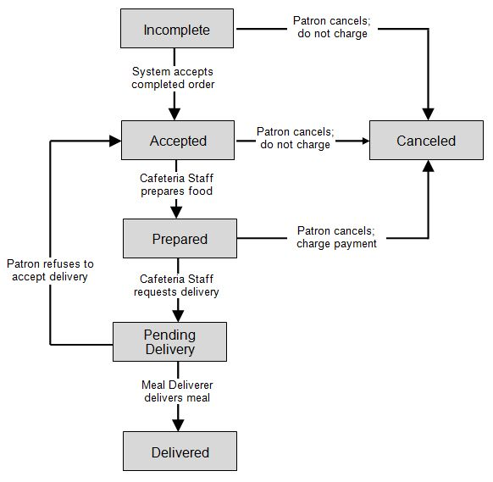
>>

3. <<Feature Name 1>>

3.1 <<Function Name 1>>
[A function can be a screen or a non-screen function (listed in the part 5.1 above). In this part, you need to provide the details on the related function, focus on mentioning below information
- Function trigger: how this function is triggered (navigation path, a timing frequency, etc.
- Function description: actors/roles, purpose, interface, data processing, etc.
- Screen layout: mockup prototype of the screen, sample below is for Manage Products screen
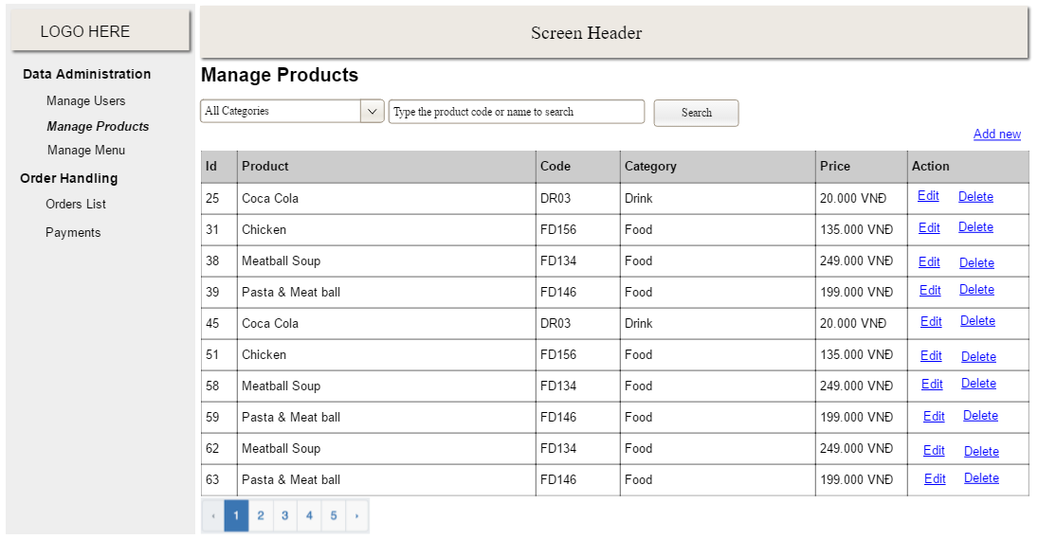
- Function Details: provide explanation for the data, validation, business logics, functionalities (for both normal cases and abnormal cases), etc. of the function so that the reader can image how it work.
]

3.2 <<Function Name 2>>
…

4. <<Feature Name 2>>
…

